Vehicle Requisition form
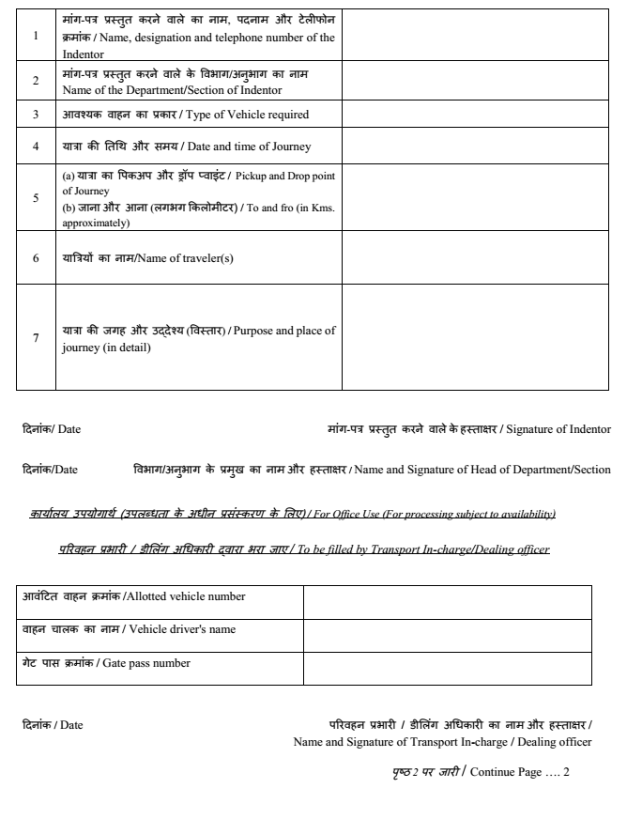
To be filled by Office of the Director
Any remarks:

Date: Director

The copy of duly approved vehicle requisition form handed over to allotted driver for his future reference

Date: Signature of Transport In-charge/Dealing officer

Vehicle Driver should keep the duly filled requisition for future references and filled properly for future reference
Please Note:
- All columns overleaf must be properly filled-in and sent to transport section (Transport In-charge/Dealing officer) either in hardcopy or through email to drmanju.icmr@hotmail.com failing which the requisition may not be considered.
- The vehicle against requisition will be confirmed subject to the availability by the Transport Section through mail / mobile to the concerned requisitioner.
- The requisition for the vehicle should reach Transport section at least 48 Hours in advance.
- Overloading of the vehicle beyond seating capacity is not permitted.
- Deviation of route is not permitted. If logged distance significantly exceeds approved distance, trip will be treated as private.
- All the official requisitions must bear the signature of recommending authority/HODs otherwise the requisition may not be entertained.
- Submitting requisition for vehicle does not ensure that vehicle is reaching unless the same is confirmed to the indenter by Transport Section.

Transport In-Charge: Dr. Manjunathachar HV, Scientist-C

